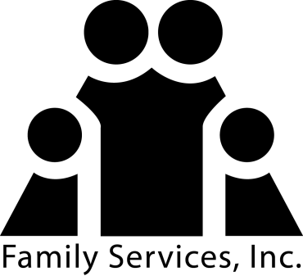
Press Inquiries:
Jenna Johnson
843.735.7854 (direct)
843.735.7855 (fax)
jjohnson@fsisc.org

FOR IMMEDIATE RELEASE

Study Shows Housing Education Could Prevent Mortgage Default for First-time Homebuyers
Educated Homebuyers One-Third Less Likely to Have Serious Mortgage Trouble

NORTH CHARLESTON, S.C. (March , 2013) – The Homeownership Resource Center (HRC), a division of Family Services, Inc. (FSI), today announced the results of new research on the effectiveness of NeighborWorks pre-purchase housing counseling and education which shows that homebuyers who received such advice were one-third less likely to fall behind on their mortgages 90 days or more, two years after taking out the loan, compared to homebuyers who didn’t receive similar counseling and education. The research was done by Neil Mayer and Associates and Experian for NeighborWorks America, a national nonprofit affiliated with HRC, and is based on approximately 75,000 mortgage loans originated in 2007, 2008 and 2009.

“Mortgage delinquency and foreclosure, continue to be stubbornly high here in Charleston, S.C. and throughout the country. This new research clearly tells us what works to help families with their housing issues ahead of time, preventing family stress, financial difficulties and costs that are borne by neighbors and the city,” said Debbie Kidd, HRC’s Director.

The research findings have important implications for HRC and the entire housing counseling and education industry. “While we have long known that pre-purchase housing counseling and education provided by our certified professionals is effective at helping to create homeowners who are less likely to default, this research actually proves it,” said Kidd.

The research could also become an important tool for lenders in the Charleston Tri-County area. Because homebuyers who receive NeighborWorks pre-purchase housing counseling and education are less likely to be three months or more late on their mortgage, the likelihood of foreclosure or other default-related costs are reduced, helping a lender’s or servicer’s bottom line.

“Supporting pre-purchase housing counseling by certified staff affiliated with NeighborWorks organizations like ours is a win-win for the homebuyer and the mortgage industry,” said Kidd.

The NeighborWorks America research shows how a small investment up front that finances the availability of pre-purchase housing counseling and education can help homeowners avoid financial losses by potentially preventing serious delinquency that has a good chance of extending into foreclosure, help prevent disruption of family life, and help keep communities stable that might be hurt by home foreclosure.

Estimates vary, but total losses due to foreclosure borne by local governments, servicers and households can exceed $50,000 per foreclosure, according to a report from the Joint Economic Committee of the U.S. Congress.

According to the Mortgage Bankers Association National Delinquency Survey for the fourth quarter of 2012, the percentage of residential mortgage loans 90 days or more past due across the country was 6.78 percent, and 3.74 percent of homeowners nationwide were in foreclosure. By providing NeighborWorks pre-purchase housing counseling and education to more consumers, it’s likely that tens of thousands of the more than 1.5 million homeowners who received a default notice in 2012 may have been able to avoid entering foreclosure.

Repeat Homebuyers

Interestingly, the NeighborWorks America research shows that even repeat homebuyers benefit from receiving NeighborWorks pre-purchase housing counseling and education. According to the report, repeat homebuyers who received the services also are about one-third less likely to fall 90 days or more behind in their mortgages than repeat homebuyers who didn’t receive NeighborWorks pre-purchase housing counseling and education.

“More analysis of the data is required to determine the factors for the repeat homebuyer results,” said NeighborWorks America CEO Eileen Fitzgerald. “But one thing is clear from the data: housing counseling is effective, even if you’ve been a homeowner before.”

About Family Services, Inc. (FSI): Family Services, Inc. has remained one of the leading human service companies by providing professional financial, housing, and health counseling services to residents and businesses of South Carolina for more than 120 years. FSI has successfully withstood the test of time and socio-economic changes by providing quality service to individuals and families. The Homeownership Resource Center, a division of FSI, provides financial literacy education, homebuyer education, and foreclosure prevention services. Call toll free TODAY at 800-232-6489 ext. 7862 or locally at 843-735-7862. For more information, go to www.fsisc.org or email info@fsisc.org.

